For Immediate Release:
CONTACT: Cynthia Stevenson cstevenson@adrmediaenterprises.com
240-472-0198 for bookings and questions

ADR (Media) Enterprises

Charming Son Productions presents Black Nancy with Author Lennox Nelson
ABOUT THE AUTHOR
Lennox Nelson is a native south Philadelphian and alumnus of Syracuse University. Nelson’s vast experiences from his world travels has enriched his life with future stories to be told. Black Nancy, his first novel, adapted from his original screenplay of the same title, was written to be shared with today’s youth to teach them about African-American history in a way in which they could be proud.
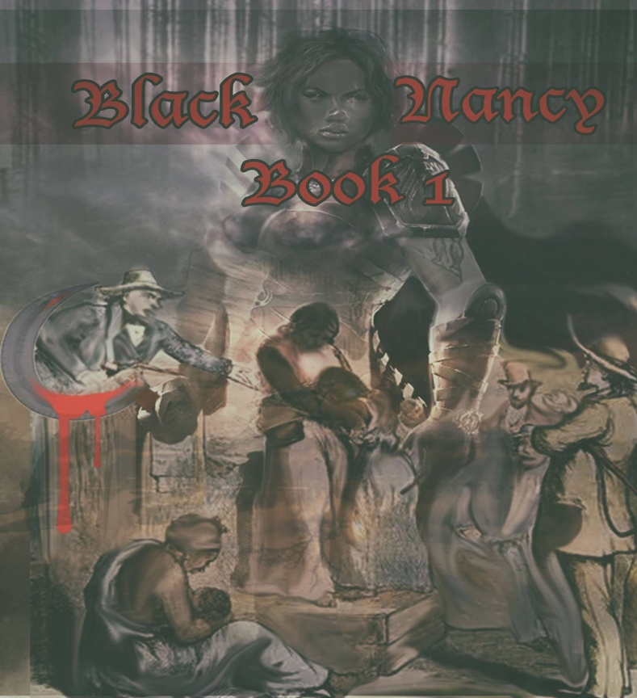Who is Black Nancy? A PRINCESS. A WARRIOR. A LOVER. A MOTHER. A PRISONER. A CHAMPION. A TEACHER. A FUGITIVE. A FOLK HEROINE. A REVOLUTIONARY.
Black Nancy was written to be shared with today’s youth to teach them about African-American history in a new and entertaining way—one in which they can be proud.
“May this stir the inner warrior inside you.”
OWN YOUR JOURNEY ~ OX
Link to Official Trailer for Black Nancy Book 1
https://www.dropbox.com/s/2m2o3uehybhx6ns/Black%20Nancy%20Web%20Version.mov

MEDIA
Include your contact information, special instructions, and any invites. For more information or Media passes contact Cynthia Stevenson, Event Organizer, directly at 301-383-0781 or 240-472-0198 or email at cstevenson@adrmediaenterprises.com, and please include a link to your press page/media section of your website.
GENERAL PUBLIC
The public is welcome to attend.
###

